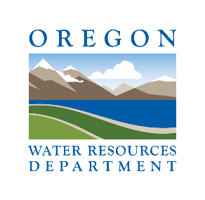

Oregon Water Conditions Report

August

26

th

, 2024

# HIGHLIGHTS

Thus far in 2024, there is [one Oregon county](https://apps.wrd.state.or.us/apps/WR/drought_dashboard/Default.aspx) with a state drought declaration under ORS 536.

According to the [US Drought Monitor,](https://droughtmonitor.unl.edu/CurrentMap/StateDroughtMonitor.aspx?OR) over 66% of Oregon is experiencing moderate (D1) to severe drought (D2) conditions. In the past two weeks, severe drought has emerged in southwestern and southeastern Oregon.

[Over the last two weeks,](https://wrcc.dri.edu/cgi-bin/anomimage.pl?ore14dPdep.png) most of Oregon received above normal precipitation especially in southwestern Oregon where precipitation was 1.5 to 3.75 inches above normal. Across western and parts of central and eastern Oregon, precipitation was less than 0.75 inches above normal. Precipitation in isolated parts of central and eastern Oregon was below normal with less than 0.25 inch of accumulated precipitation.

Temperatures [over the last two weeks](https://wrcc.dri.edu/cgi-bin/anomimage.pl?ore14dTvdep.png) were below normal for most of the state, most notably in southcentral Oregon where temperatures were 4°F to 8°F below normal. Along the coast and in parts of northeastern Oregon, temperatures were up to 2°F above normal.

[Recent soil moisture indicators](https://weather.ndc.nasa.gov/cgi-bin/basicLooper.pl?category=lis_NWUS&initialize=first&regex=swetdiff14_20240812) show a slight increase in soil moisture in southwestern Oregon and small parts of western and eastern Oregon. Along the coast and in scattered parts of central and eastern Oregon there has been a minimal decrease in soil moisture.

The [8-14 day climate outlook](https://www.cpc.ncep.noaa.gov/products/predictions/long_range/seasonal.php?lead=1) indicates above normal temperatures are likely for the entire state and probabilities are leaning towards above normal precipitation statewide.

[Recent](https://waterwatch.usgs.gov/index.php?r=or&id=pa07d) streamflow conditions over the past seven days have varied across the state. Along and west of the Cascades, streamflow conditions were generally near to above normal with some exception. In central and eastern Oregon, streamflow was generally below normal. Streamflow over the past 28 days shows a similar trend in variability across the state but with less above normal streamflows. In northeastern and across parts of southern Oregon, well below normal streamflow conditions were recorded.

Reservoir storage in many basins is currently near to above average. However, projects in the Deschutes, Powder, and Rogue basins are measuring below average. See [USBR](https://www.usbr.gov/pn/hydromet/select.html) (including [Klamath)](https://www.usbr.gov/pn/hydromet/klamath/teacup.html) and [USACE](https://www.nwd-wc.usace.army.mil/nwp/wm/teacups.html) teacup diagrams for more information.

[Significant wildfire potential](https://gacc.nifc.gov/nwcc/predict/outlook.aspx) over the next seven days ranges from low to elevated throughout the Pacific Northwest. Parts of central and eastern Oregon are projected to have an elevated risk by the end of the week.

1

# DROUGHT CONDITIONS

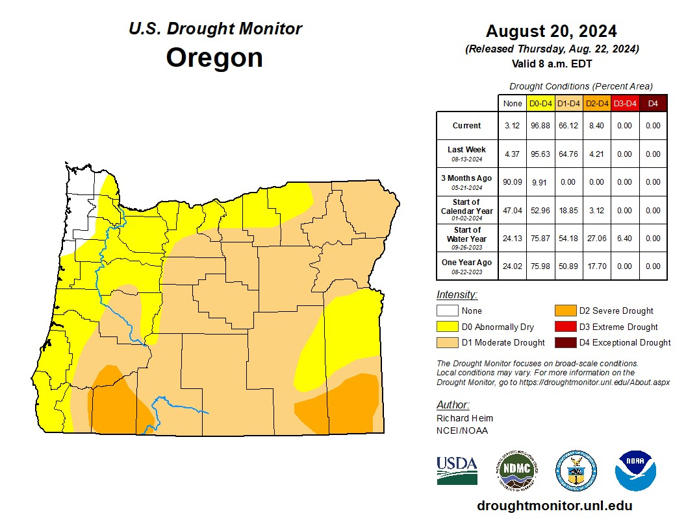

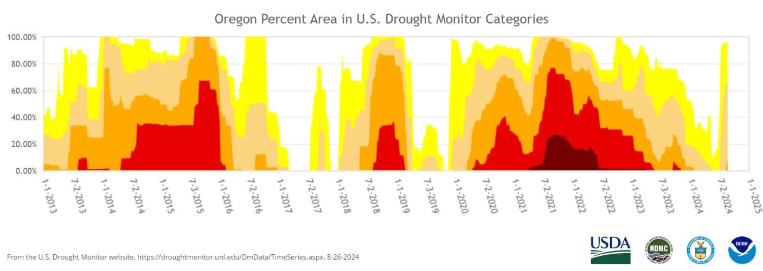

2

**PRECIPITATION**

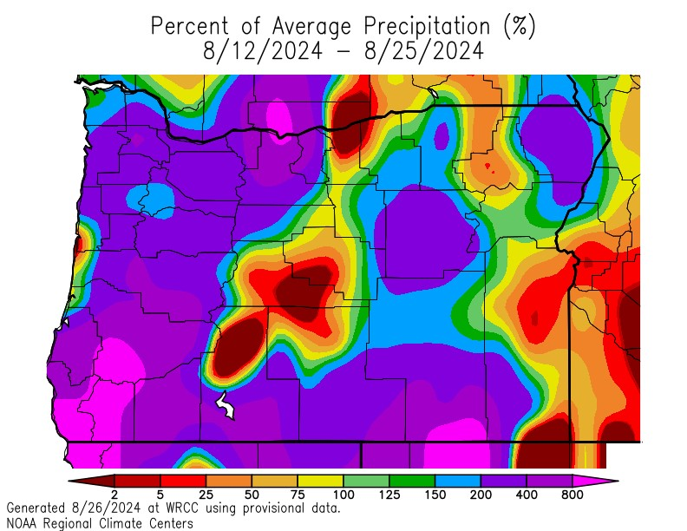

**TEMPERATURE**

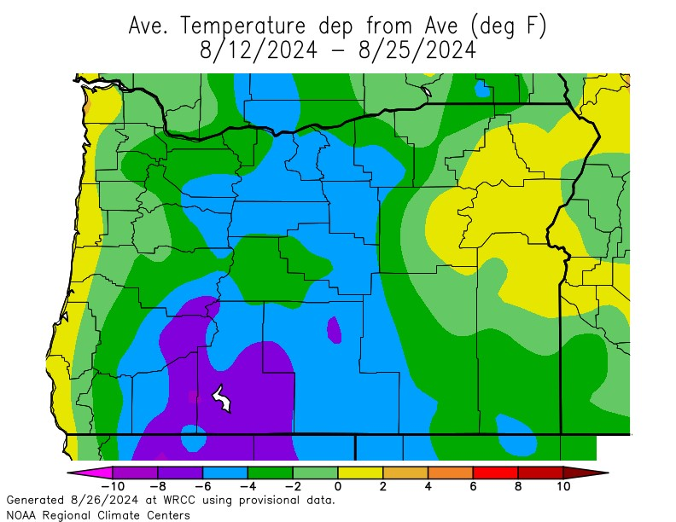

# SOIL MOISTURE

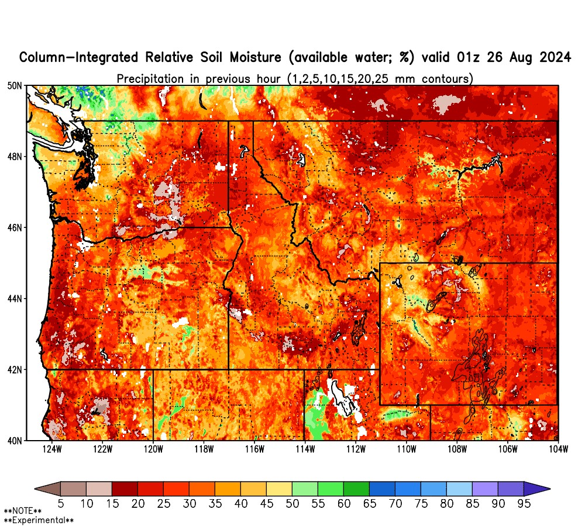

# CLIMATE OUTLOOK

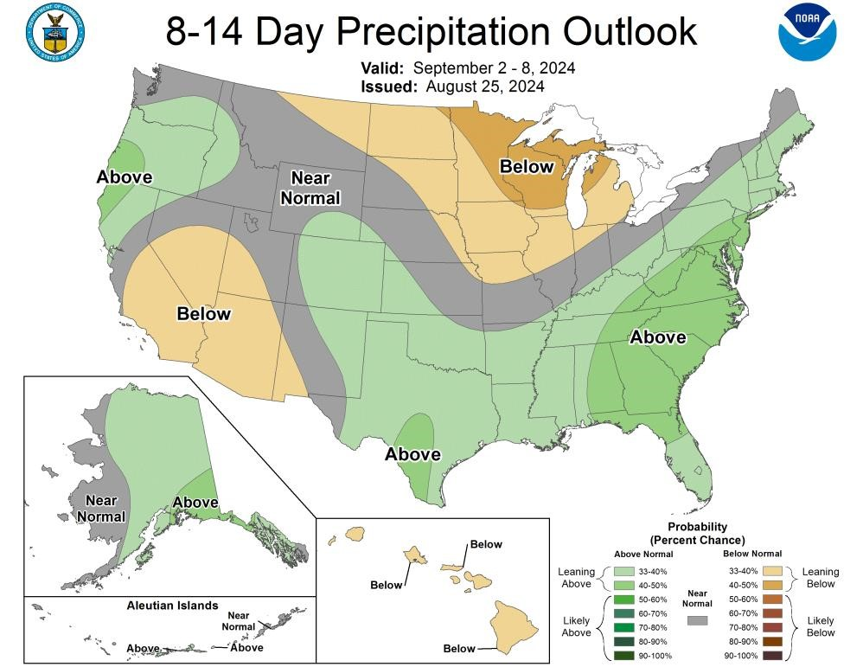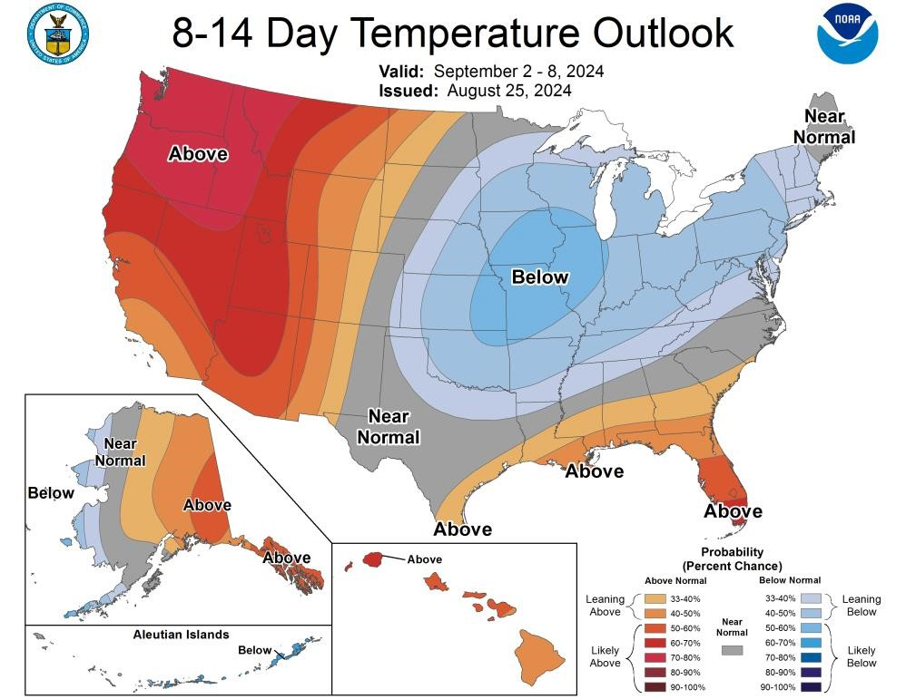

# STREAMFLOW

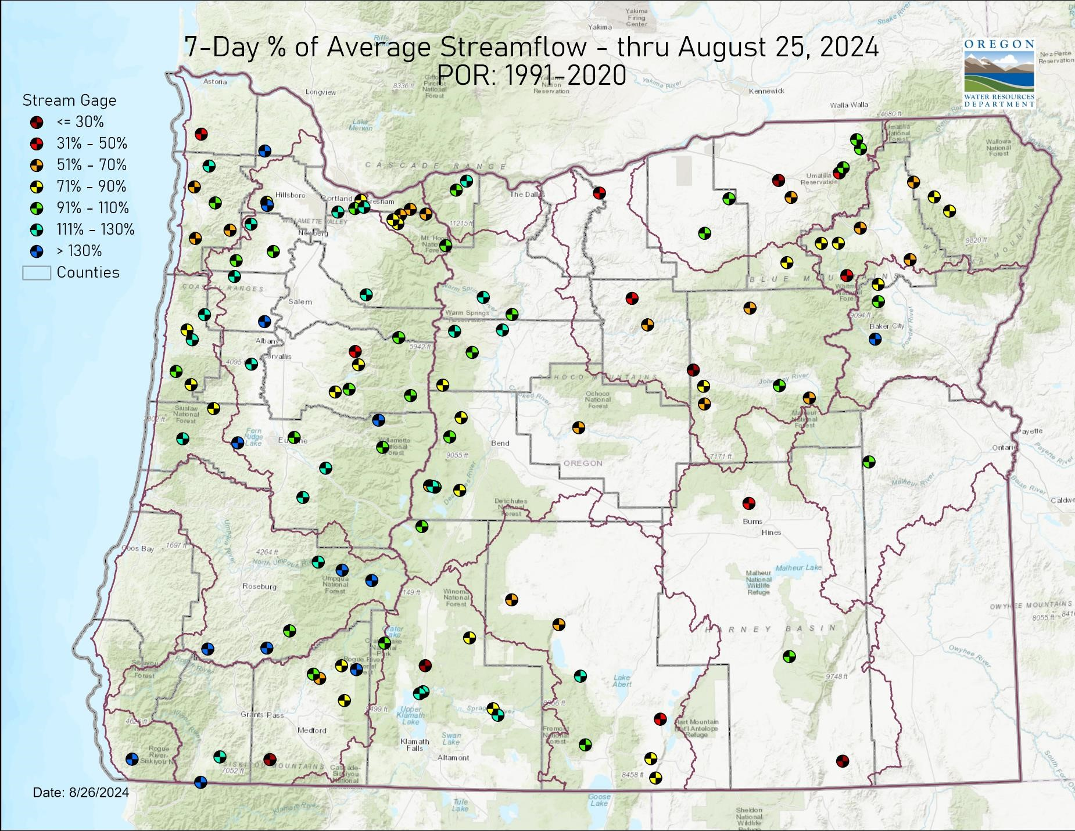

# STREAMFLOW

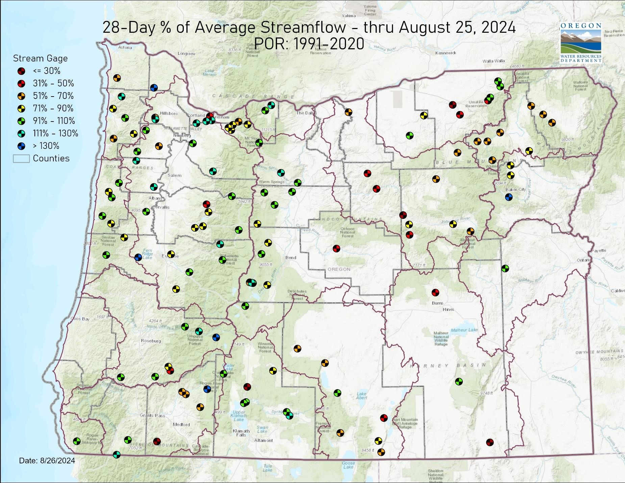

**STORAGE**

# August 25 Reservoir Storage

**%**

**71**

**49**

**%**

**33**

**%**

**33**

**%**

**33**

**%**

**%**

**68**

**35**

**%**

**50**

**%**

**64**

**%**

**%**

**169**

**%**

**169**

**106**

**%**

**87**

**%**

**75**

**%**

**114**

**%**

**%**

**68**

**%**

**100**

**109**

**%**

**0**

**%**

**20**

**%**

**40**

**%**

**%**

**60**

**80**

**%**

**%**

**100**

**120**

**%**

**140**

**%**

**160**

**%**

**%**

**180**

**Owyhee**

**Malheur**

**Burnt**

**Powder**

**Deschutes**

**Crooked**

**Rogue**

**Umatilla**

**Tualatin**

**Percent Full**

**Percent of Average**



## WILDFIRE

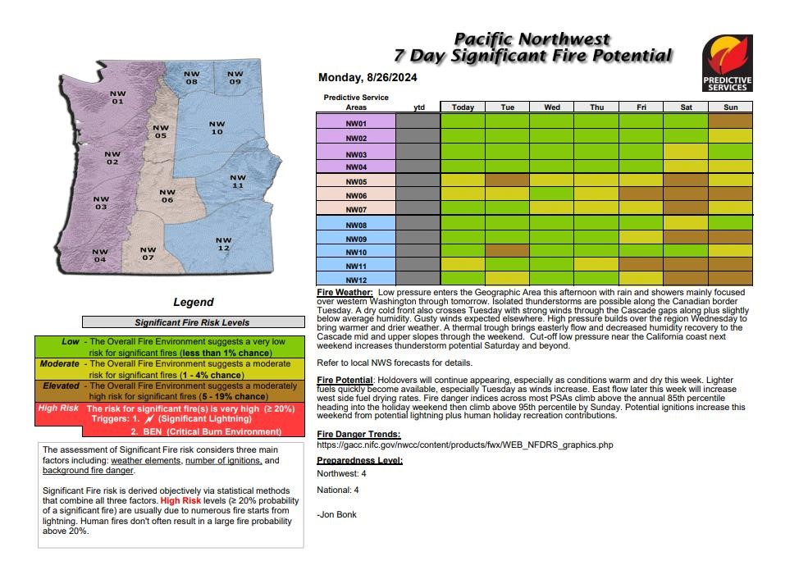

## RESOURCES/REFERENCES

Please visit [Oregon Water Resources Department’s drought information page](https://www.oregon.gov/owrd/programs/climate/droughtwatch/Pages/default.aspx) to learn about current drought conditions, assistance programs, and potential drought tools.

If you are interested in submitting local drought-related conditions and impacts, please visit the [drought impacts toolkit](https://droughtimpacts.unl.edu/ConditionMonitoringObservations.aspx) to learn more. Click here to visit the map of condition monitoring observer reports.

Released every Thursday, the [US Drought Monitor](https://droughtmonitor.unl.edu/) provides a weekly assessment of drought conditions. The USDM provides a [network infographic](https://droughtmonitor.unl.edu/data/docs/USDM_network.pdf) which depicts the network of observers who gather and report information about conditions and drought impacts.

The [WestWide Drought Tracker](https://wrcc.dri.edu/wwdt/about.php) uses data from [PRISM](https://prism.oregonstate.edu/) to provide easy access to finescale drought monitoring and climate products, such as the figures depicting climate conditions within this report.

The National Weather Service’s [Climate Prediction Center](https://www.cpc.ncep.noaa.gov/) offers [weekly,](https://www.cpc.ncep.noaa.gov/products/predictions/814day/) [monthly,](https://www.cpc.ncep.noaa.gov/products/predictions/30day/) and [seasonal](https://www.cpc.ncep.noaa.gov/products/predictions/90day/) climate outlooks illustrating the probabilities of temperatures and precipitation.

The [Regional Climate Centers](https://wrcc.dri.edu/wwdt/about.php) (RCC) working with NOAA partners, deliver climate services at national, regional, and state levels. Climate [anomaly maps of Oregon](https://wrcc.dri.edu/wwdt/index.php?folder=pon1) are updated daily at around noon PST.

NASA’s [Gravity Recovery and Climate Experiment](https://nasagrace.unl.edu/Default.aspx) (GRACE) provide satellite-based observations of soil moisture conditions that are useful as drought indicators, helpful in describing current wet or dry soil conditions.

USGS [Water Watch](https://waterwatch.usgs.gov/index.php?m=pa07d&r=or&w=map) provides maps of real-time and average streamflow conditions at USGS sites throughout the state.

Reservoir storage “teacup” diagrams are offered by both the [US Bureau of Reclamation](https://www.usbr.gov/pn/hydromet/select.html) and [US Army Corps of Engineers.](https://www.nwd-wc.usace.army.mil/nwp/wm/teacups.html) The diagrams represent the level of fill in the reservoirs as both percent full and as a ratio of volume of water currently in the reservoir to the volume of water in the reservoir when it is full.

Oregon wildfire information can be found through [InciWeb](https://inciweb.nwcg.gov/) and the Oregon

Department of Forestry’s [Wildfire News,](https://odfwildfire.wpengine.com/) along with the [National Interagency Fire Center](https://www.predictiveservices.nifc.gov/outlooks/outlooks.htm) which offers outlooks on the significant wildland fire potential.

Oregon Office of Emergency Management maintains a [hydrology/meteorology dashboard](https://geo.maps.arcgis.com/apps/opsdashboard/index.html#/be408c0ef4a14dd6ad25d181a27b2a54) which shows state and local drought declarations, as well as hosts many of the data sources to generate this report. Use the selection arrows at the bottom of your browser to navigate through the various sources.

US Department of Agriculture provides the [Weekly Weather and Crop Bulletin](https://www.usda.gov/sites/default/files/documents/wwcb.pdf) as a vital source of information on US and global weather, climate, and agricultural developments, along with seasonally appropriate agrometeorological charts and tables. USDA’s [Drought Programs and Assistance](https://www.usda.gov/topics/disaster/drought/usda-drought-programs-and-assistance) offers links to programs and resources to help those struggling with persistent drought.

11