MID NEWSLETTER

2024

|  |
| --- |
| When and How to Water Pear Trees | Gardener's Path |

|  |  |  |  |
| --- | --- | --- | --- |
|  | |  |  |
| **JUST A LITTLE HISTORY**  The first irrigation water supply for lands within the district’s area was obtained from Bear Creek and its tributaries. Fish Lake Water Company was organized in 1897 to bring water into the valley from outside sources. Water rights were obtained on Little Butte Creek and a storage dam at Fish Lake and canals from the North and South Forks of Little Butte Creek were constructed. The delivery of water from these sources began in 1902.  The Fish Lake Ditch Company sold its interests to the Public Water Company in 1908 and this organization operated the system under various names until 1930. Enlargements were made to the system in 1908 and again in 1915 and 1916, but they were inadequate to furnish and deliver the necessary supply of water. The Medford Irrigation District was formed in 1917 with the objective of developing new sources of water to provide a supply to lands not previously irrigated. The district contracted with the Rogue River Valley Canal Company (not to be confused with Rogue River Valley Irrigation District), successors to the Public Water Company; to construct Fourmile Lake Dam and the Cascade Canal, reconstruct Fish Lake Dam and complete the distribution system within the district.  2024 HOLIDAYS MID WILL BE CLOSED: May 27th Memorial Day  July 4th Independence Day  Sept. 2nd Labor Day  ________________________  **BOARD MEETINGS:**  MAY 8TH @ 1:30pm  JUNE 12TH @1:30pm  JULY 10TH @ 1:30pm  AUGUST 14TH @ 1:30pm  SEPTEMBER 11TH @ 1:30pm  OCTOBER 9TH @ 1:30pm | | Hours of operation MID OFFICE HOURS APRIL thru OCTOBER  8:00 AM – 4:30 PM  NOVEMBER thru MARCH  7:30 AM – 4:00 PM   |  | | --- | | _________________________  **Staff:**  Manager: Jack Friend  Office Mgr: Tammi  Office Asst: Dusk  East Side Supervisor: Jacob  West Side Supervisor: Dan  Maintenance: Manuel | | CONTACT INFORMATION CONTACT US… OFFICE: 541-899-9913  FAX: 541-899-9968  Website: www://medfordid.org  Email: [medid@medfordid.org](mailto:medid@medfordid.org)  Emergency Line: 541-770-0277  ___________________________  **Ditch Riders:**  Ride 1: Jacob  Ride 2: Carlos  Ride 3: Jadd  Ride 4: Dan  **Relief Riders:**  Ride 1&2: Jose  Ride 3&4: Diego |
|  |  | |  |
|  | |  |  |
|  | |  |  |

|  |  |
| --- | --- |
| Vineyard, Orchard and Berry Irrigation ... Alert the office if you… Sold your property, have a name change that coincides with Jackson County records, new mailing address and/or phone number, email address and/or haven’t received your annual billing.  **Sign up for updates on our website or call our office and we can sign you up.**  **Additionally….**  Report any violations that you may see on or around our infrastructure of canals, laterals, equipment, and theft of water as well. Working together will help make deliveries smoother and the availability of water for everyone. | Mission Statement  To deliver water equitably and efficiently with the least amount of cost to its water users, keeping in mind the need for long-range planning and environmental impact. Through leadership, use of technical expertise, efficient operations, responsive customer service, and the creativity of people, Medford Irrigation District will seek to protect and preserve local natural and ecosystems through the effective use of water. **MAINTENANCE 2024** Canal, road, and right-of-way maintenance is in full swing. Please remember to keep debris, etc. from blocking our access for operations and maintenance of MID infrastructure. Cleanings that we accumulate by excavating the canals is returned to the canal roads and canals itself for reshaping of the canals. We use flail and rear mowers mounted to our tractors for maximum clearing area.  **REMEMBER: IRRIGATION WATER IS NON-POTABLE! KEEP ANIMALS AND CHILDREN AWAY FROM THE CANALS FOR THEIR SAFETY AS WELL.** |

|  |  |
| --- | --- |
|  | Irrigation and Pipes Used for Agriculture |
| *Board of directors* 2024  **DIVISION 1 - Dennis O’Donoghue**  EMAIL: Dennis@medfordid.org  **DIVISION 2 - Sean Naumes**  EMAIL: Sean@medfordid.org  **DIVISION 3 - Henry Vaninetti**  EMAIL: Henry@medfordid.org  **DIVISION 4 - Matt Borman**  EMAIL: Matt@medfordid.org  **DIVISION 5 - Tom Brookins**  EMAIL: Tom@medfordid.org | The Board Chair & Your Nominating Committee: Why They're So Important -  Foundation Group®  **ELECTIONS** |
| **Important Dates to remember:**  August 29, 2024, thru October 8, 2024 @ 5pm, is the nominating petition period for a new/current board member to cast their name for the open position for their division.  This year’s board seats that are up for election are: Divisions 1,3, and 4. |  |

|  |
| --- |
|  |

Floating Community Solar Project

In the spring of 2020, the Oregon Clean Power Cooperative (OCPC) reached out to discuss the opportunities and considerations of installing a floating community solar project on the re-regulation reservoir located next to the district’s office. Similarly installed projects in other locations have shown a number of potential benefits. Depending on the location and climate conditions, floating solar projects are estimated to reduce reservoir evaporation rates by 10%. Floating solar may also inhibit the growth of algae and other aquatic plants below the panels. Further, as an Oregon Community Solar Program project, the energy generated by the system could benefit both the district and our water users. Under the program’s rules, 40% of the energy would be made available to MID, 50% would be made available to offset the residential use of individual district irrigators, and 10% would be reserved for low-income Oregonians. Depending on the amount of grants or other outside funding that is able to be brought to the project, the district and individuals that subscribed to the project would see an immediate reduction in energy costs with no out-of-pocket expense. The project would be both the first floating solar installation in Oregon and the first Community Solar Project in the state directly targeted to support agriculture. The board felt these potential benefits made a project worthy of additional consideration. Farmers Conservation Alliance (FCA) worked with OCPC to further review the project and provided funding to support an early-stage interconnection study with Pacific Power to determine if the utility’s electrical grid could support a project at that location. The interconnection study indicated a project could likely go forward successfully, but further financial feasibility analysis showed that the project had costs that – at the time – were not easily offset by available grants. Over the last two years, grant funding opportunities expanded, and the project is now moving forward with further development activities. In March of this year, FCA and OCPC developed an application for a Congressionally Directed Spending request in support of the project. This is the same type of funding request that was used to raise $5 million in support of the first phase of the Joint System Canal Piping Project. Now FCA and OCPC are drafting a grant application to the new Oregon Department of Energy Community Renewable Energy Program. As proposed, the system would be an 867-kilowatt photovoltaic array, resting on UV-stabilized High-Density Polyethylene (food-grade plastic) floats. The panels would be tethered to the bottom and/or sides, rising and falling like a floating dock, and would take up approximately two acres of the reservoir. The system would be expected to produce up to 1,370,000 kWh per year, with energy generated by the array appearing as a credit on subscribers’ electricity bills, lowering the costs paid to the utility for energy. Long-term monitoring will evaluate the amount of water conserved from avoided evaporation and the ability of the project to reduce the growth of algae and aquatic weeds that foul the water supply, with results shared to contribute to the advancement of similar future projects. Additional details on the project will be shared as development moves forward.

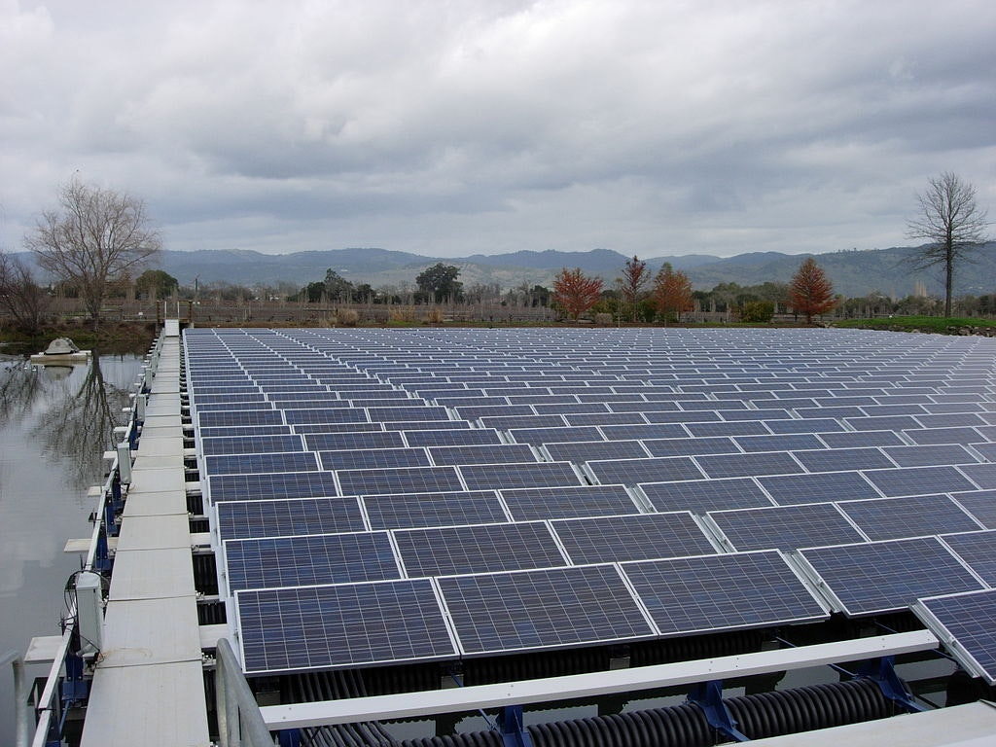

Joint System Piping Canal Project

The Joint System Canal (JSC) is a 13.6-mile irrigation canal at the beginning of both the Rogue River Valley and Medford Irrigation Districts. The JSC serves 2,200 farms and over 21,000 irrigated acres. The existing canal poses many challenges for the irrigation districts including significant maintenance costs and evaporation and seepage losses. The open water transportation and flood irrigation return flows contribute to water quality issues in Little Butte Creek and Rogue Basin.

The irrigation districts and partners are planning to pipe the entire JSC in a series of phases. Piping the canal will help the irrigation districts provide more and cleaner, pressurized water to their patrons. Water quality in the Rogue Basin and Little Butte Creek may be improved by reducing water quality impairment in water transportation and on-farm irrigation improvements that occur as a result of the project. The project will also result in instream conserved water for Little Butte Creek. JSWCD is supporting this project via outreach efforts, project design work, and pre-project water quality monitoring.

Watershed Plan EIS Project

Medford, OR - (July 27, 2023) – Medford Irrigation District (MID), in partnership with the U.S. Department of Agriculture Natural Resources Conservation Service (NRCS) in Oregon, proposes to modernize the Joint System Canal to improve efficiency and reduce water loss. MID is the project sponsor and Rogue River Valley Irrigation District (RRVID) is a partner organization. Agricultural production in both districts depends on the ability to deliver water effectively and efficiently through the Joint System Canal, particularly during drought years when water supplies are limited.

By converting the 13-mile open Joint System Canal into a piped or lined system, the proposed project would reduce conveyance and operational losses and improve water delivery to patrons in both MID and RRVID. NRCS in Oregon is providing funding and technical support and Farmers Conservation Alliance is assisting with the planning process as a contractor.

## a word from our manager

Jack Friend

#### As of June 28, 2024, our combined water supply in Fourmile and Fish Lake is 54% of full pool. That is 76% of the average for this time of year. The supply is like last year but slightly less storage (750 A/F). The Talent supply we get out of Emigrant is at 40% or 3,185 A/F. We have started using stored water as of June 13th and the outlook is similar to last year when we made it into the middle of September. Weather patterns and demand will have an impact on the supply and decisions for the end of our irrigation season. Please sign up for our email updates online at [www.Medfordid.org](http://www.Medfordid.org) for the most up-to-date information.

MEDFORD IRRIGATION DISTRICT

PO BOX 70

JACKSONVILLE, OR 97530

**Sign up for updates on our website or**

**call our office and we can sign you up.**