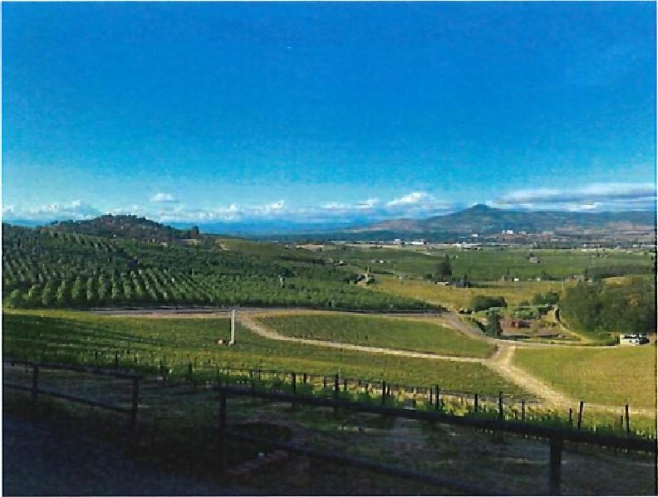PROTECTING WATER USE IN THE ROGUE BASIN

The Issue—Klamath Basin Adjudication; Fourmile Lake Call. In 2013 the Klamath Basin Adjudicator issued official findings and the Oregon Water Resources Department ( 'ÉOWRD") began regulating junior water rights in the Klamath Basin for the first time. Senior water right claimants with pre1909 priority dates were able to place a "call/' shutting off water use by junior water right holders.

Impacts on the Rogue Valley. Why does this matter to residents of the

Rogue Valley? Three irrigation districts (Talent, Medford, and Rogue River Valley) (the U Districts") supply irrigation to over 35,000 acres, municipal and industrial water in the Rogue Basin. The Districts depend in part on a 1910 water right to store and move water from Fourmile Lake in the Cascade Mountain Range over to the Rogue Basin. The use of that Fourmile Lake water right is now in jeopardy because the Klamath Basin Adjudicator granted several very large senior priority claims by the federal government on behalf of the Klamath Tribes, the Bureau of Reclamation, and the United States Fish and Wildlife Service. In late August 2013, OWRD issued a headgate order requiring the Districts to install a bypass facility to allow delivery of water from Fourmile Lake into the Fourmile Creek drainage in the Klamath Basin. Fourmile Lake Dam does not have any outlet works or bypass facilities to release waters into Fourmile Creek, a tributary of Upper Klamath Lake. Per the 2014 Consent Order the bypass facility design and capacity must be approved by OWRD. The Districts have not received this approval from OWRD. The Districts' existing stored water release facilities do not intersect Fourmile Creek, further complicating the transfer of water into the Fourmile Creek drainage because that water must cross US, Forest Service land. In order to release water from Fourmile Lake into Fourmile Creek, engineering, permitting, and construction work will need to be completed.

2023 Tribal Call for Water. The Klamath Tribes asserted its Claim 622 (KA 622 priority date 1908) with an Enforcement Letter to OWRD dated March 3, 2023 leading to a call on the Districts' Fourmile Lake (priority date 1910) by OWRD dated March 10, 2023. OWRD's surface water use and regulation notices issued to Medford Irrigation District and Rogue River Valley Irrigation District prohibit releasing any water from Fourmile Lake. The two Districts hold seven water right certificates that are impacted by the Final Orders. The Final Orders significantly limit the Districts' ability to deliver water to irrigation patrons, as well as domestic, manufacturing, industrial and municipal water users, including the City of Central Point and the City of Eagle Point. In addition, the water from Fourmile Lake is used to augment flows in the Little Butte Creek system for the benefit of

Southern Oregon/Northern California Coast coho salmon, protected under the Endangered Species Act and covered by the National Marine Fisheries Service Biological Opinion for the Rogue Project. This is disastrous for our critical agricultural economy. It also impacts recreation, fish and wildlife, and aesthetic values in the Rogue Valley. By contrast, Fourmile Lake has a very small impact on the water available to senior claimants in the Klamath Basin, where there are much larger sources of water to serve senior demands,

What We Are Doing. Our legal team has been hard at work on the Klamath Adjudication for a number of years. We initially filed contests to all the claims with potential to harm the Districts' 1910 water right. We have participated in contest proceedings before administrative law judges, and participated in stay litigation before the decree judge in the Klamath County Circuit Court. In the spring of 2014, we challenged the Adjudicator's decision to award senior water rights to the federal government. We are now defending a call against the Fourmile Lake water right. In May 2023, we filed a Petition for Judicial Review, including a request for a stay of OWRD's regulation notice.

The Districts have been communicating with the Southern Oregon legislative delegation (both House and Senate members) regarding this situation. We have requested support for an initial $1 Million funding through the Oregon Drought Relief Bill for the engineering, permitting, and construction work on the Fourmile Lake Dam bypass facilities. As of May 4, 2023 this is still a line item for consideration. We are nearing the end of the State's current fiscal biennium, and there may be a need for Jackson County to facilitate bonding of these State funds to be paid out at a later date if awarded.

This information sheet has been prepared by the Rogue Basin Water Users Council, Inc. (RBWUC), which is an entity formed to handle issues and events that are common to Medford, Rogue River Valley and Talent Irrigation Districts.

Ver 5/9/23

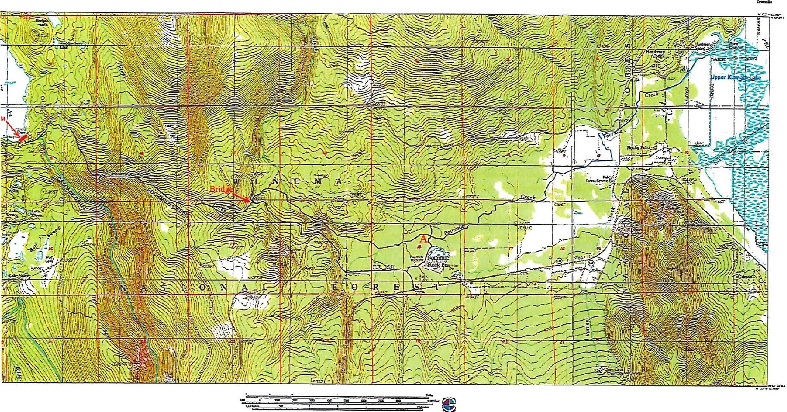

FigureNo.1ーFo白目一一el、akeしowns月ea日、\*.

Ver

5

/

9

/

23