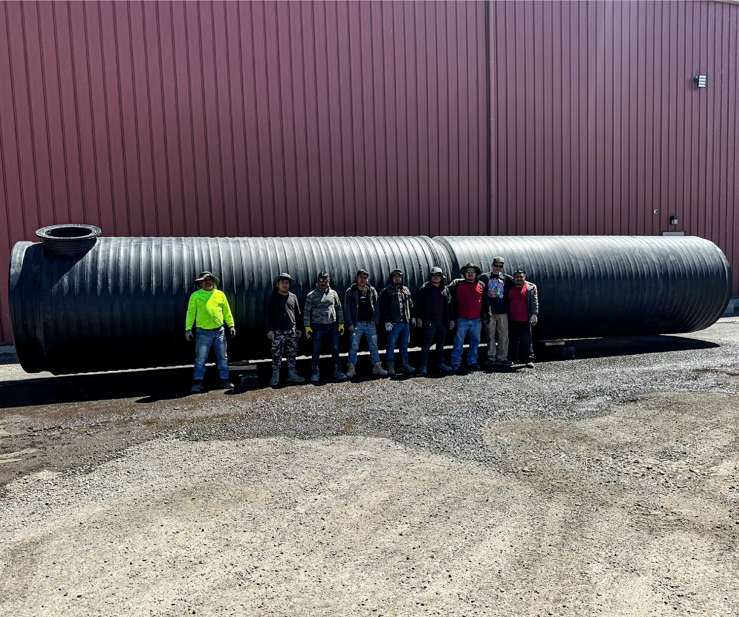
Safe Water Storage Tailored for You
TANKS
HDPE in diameters up to DN/ID 197" (5000 mm)
KRAHUSA Water Storage Tank, 72” ID/40’ L, 8200 gal

Water Storage Tanks from KRAHUSA
KRAHUSA’s water storage tanks are essential for managing water in various ways. Whether you’re keeping water clean for animals, using it for farming tasks like watering crops or cleaning equipment, or controlling humidity in greenhouses, these tanks play a crucial role. They save space and are built to last using top-notch materials and advanced techniques. These tanks resist temperature changes and chemicals, ensuring they won’t leak. They’re also eco-friendly, easy to move around, and don’t need much upkeep, lasting over a 100 years.
KRAHUSA Tanks are tough but light, making them cheaper and easier to transport and install, especially in tight spots or for quick setups. Second, they resist rust and damage from chemicals better, so they can hold different types of water, including drinking water, without falling apart like concrete might over time. They also last longer and need less fixing up. Their seamless design means fewer chances for leaks, which keeps stored water safe and clean. Plus, they’re recyclable, which is good for the environment. Overall, HDPE tanks are
a smarter pick for storing water because they’re light, strong, resistant to damage, and eco-friendly.

Tank Fabrication
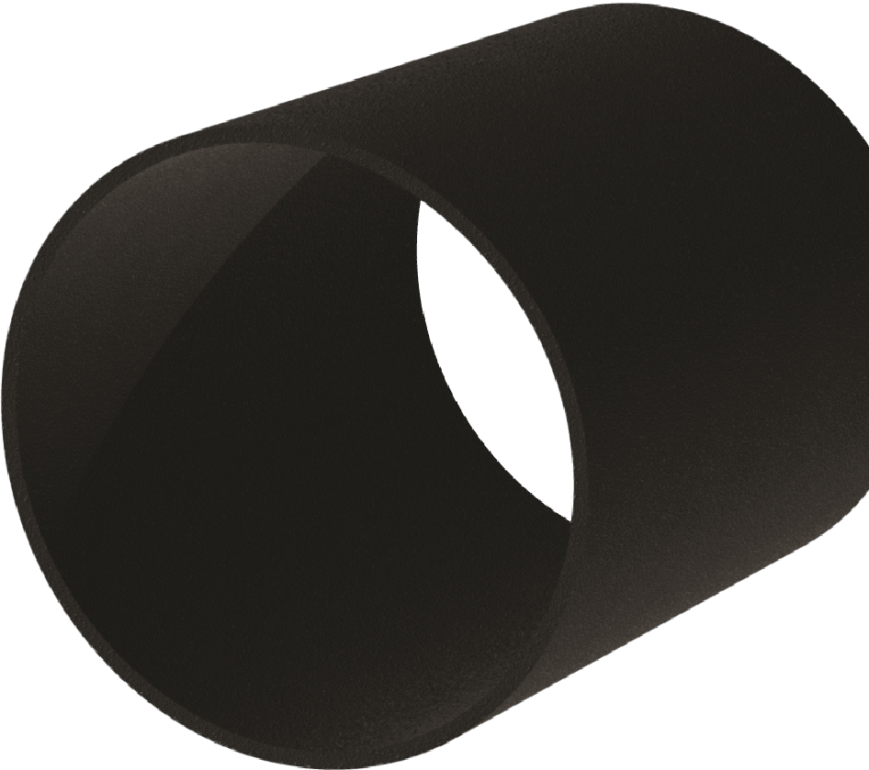
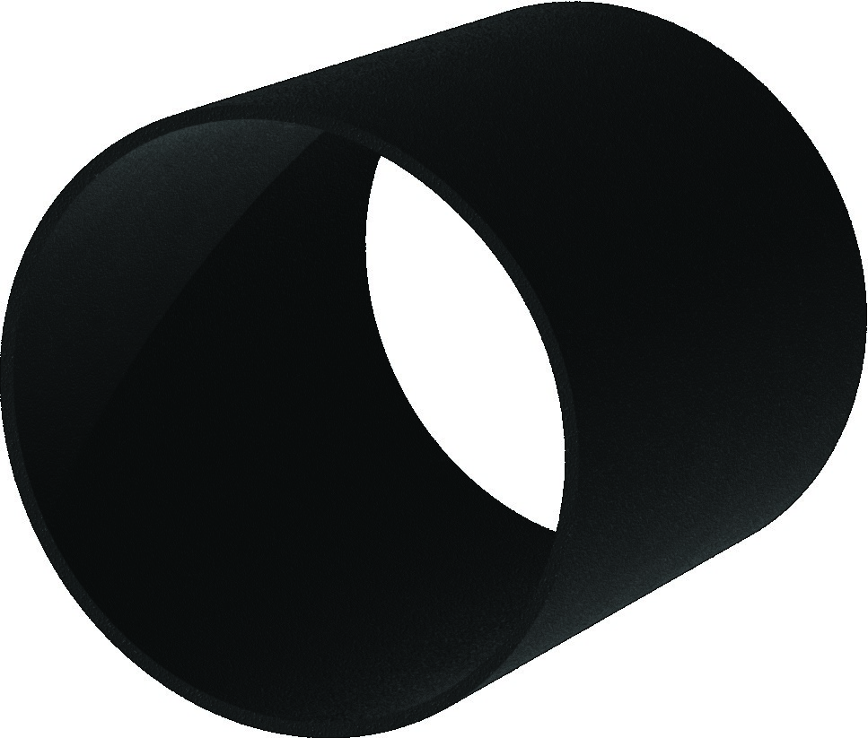

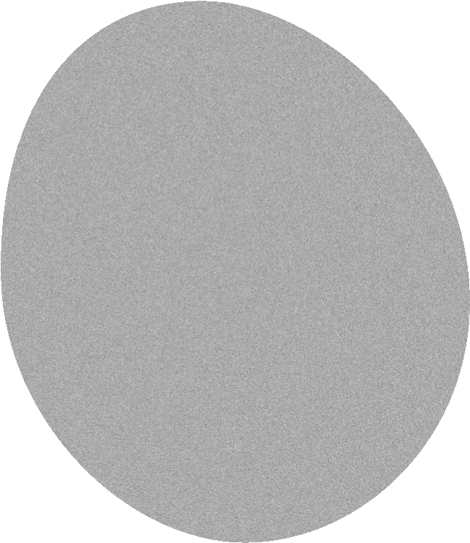





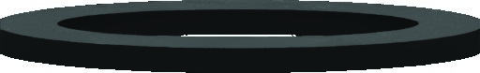
KRAHUSA’s tanks are as strong and reliable as their pipes. These tanks are made by uniformly extruding HDPE, which is a cost-effective way to create large tanks. Because of HDPE’s great properties, these tanks can handle tough liquids like acids and foods without issues. Structured wall tanks can also be made to be extra strong for burying underground or for containing chemicals safely. They’re easy to install and handle because they’re light yet tough, making them perfect for storing and processing various materials.
www.KRAHUSA.com
Copywright© 2023 KRAHUSA LLC

Fittings and Connections
Tanks can be fitted with Manway access ports, ladders and several types of fittings for filling, dispensing or integrating with water treatment and irrigation systems. Contact our Team to learn more about how we can meet your specific needs.
Tanks come with the 4” Fill Flange and 24” ANSI Flange as standard. Threaded or mechanical connections are available. Custom configurations are available to meet your specific needs.

- Service Life of
Over 100 Years
- Minimal Maintenance
- 100% Leak-free Joints
- Temperature Resilience
- Chemical Resistant
- Eco-Friendly
- Exceptional Customization
- Easy Handling
KRAHUSA LLC3840 NW Bus Evans Lane, Prineville, OR 97754
Page 2


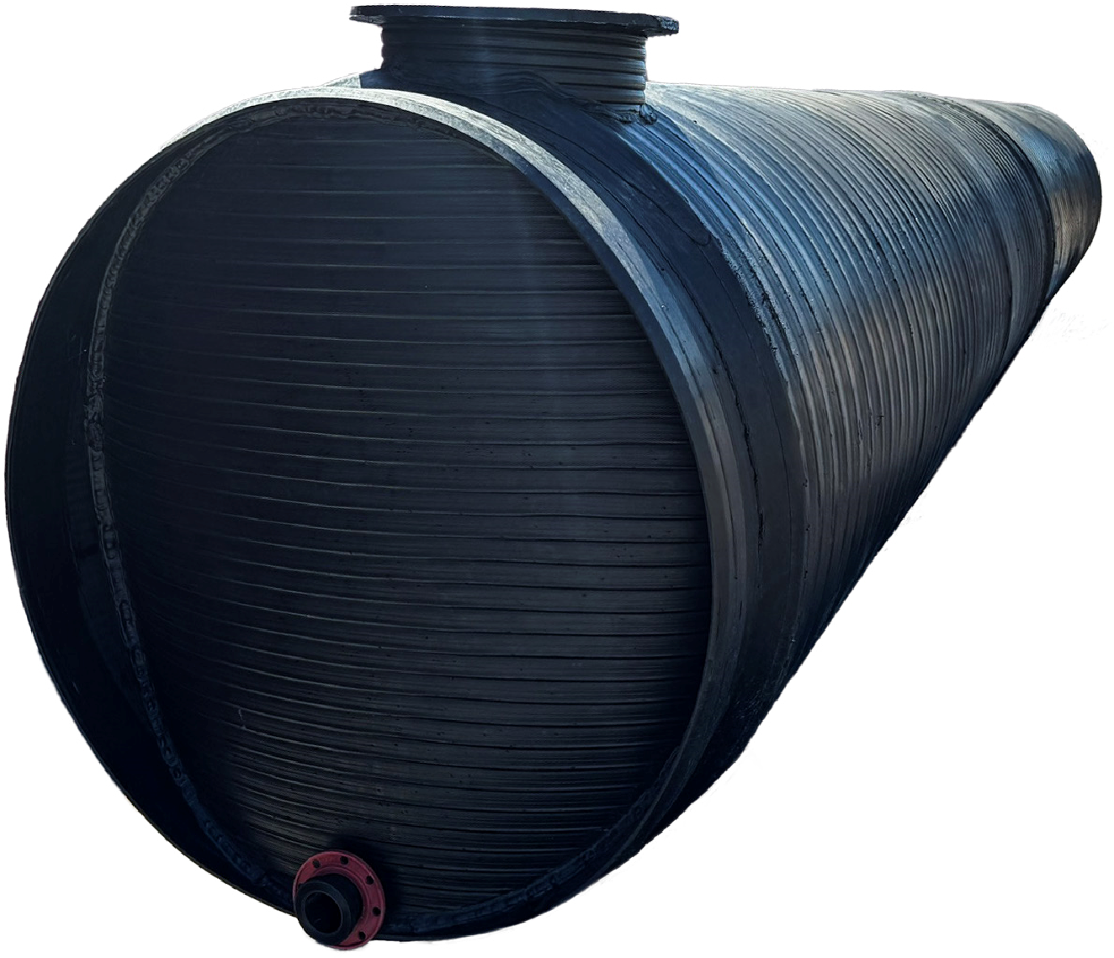
Typical Water Storage Tank Specifications
KRAHUSA LLC

www.KRAHUSA.com
3840
NW Bus Evans Lane, Prineville, OR
97754
Copywright© 2024 KRAHUSA LLC

Page 3
Customization:
If You Can Draw It,
We Can Build It
KRAHUSA specializes in making custom tanks
that fit exactly what you need. Our tanks come
in different sizes within our diameter range, so
you can store as much as you need. In vertical
setups, our tanks are designed to handle
pressure carefully, considering all conditions and
loads. We follow strict international standards
like DVS2205 and EN12573 to ensure quality.
The design of the tank walls is based on your
job’s needs, and our technology allows us to
customize the walls completely.
differ from these typical values.
DN/ID | RSC Class | Height | 20' | Volume | Weight | 40' | Volume | Weight
24” | 400 | 54 in. | 20’ | 458 gal. | 1,351 lb. | 40' | 928 gal. | 2,012 lb.
30” | 400 | 60 in. | 20’ | 716 gal. | 1,606 lb. | 40' | 1,450 gal. | 2,418 lb.
33” | 400 | 63 in. | 20’ | 866 gal. | 1,743 lb. | 40' | 1,755 gal. | 2,630 lb.
36” | 400 | 66 in. | 20’ | 1,031 gal. | 1,886 lb. | 40' | 2,089 gal. | 2,847 lb.
42” | 400 | 72 in. | 20’ | 1,403 gal. | 2,189 lb. | 40’ | 2,843 gal. | 3,300 lb.
48” | 250 | 78 in. | 20’ | 1,833 gal. | 2,516 lb. | 40’ | 3,713 gal. | 3,776 lb.
54” | 250 | 84 in. | 20’ | 2,320 gal. | 2,864 lb. | 40’ | 4,699 gal. | 4,273 lb.
60” | 250 | 90 in. | 20’ | 2,864 gal. | 3,486 lb. | 40’ | 5,802 gal. | 5,291 lb.
66” | 250 | 96 in. | 20’ | 3,466 gal. | 3,906 lb. | 40’ | 7,020 gal. | 5,884 lb.
72” | 250 | 102 in. | 20’ | 4,124 gal. | 4,421 lb. | 40’ | 8,355 gal. | 6,642 lb.
78” | 250 | 108 in. | 20’ | 4,840 gal. | 4,893 lb. | 40’ | 9,805 gal. | 7,292 lb.
84” | 250 | 114 in. | 20’ | 5,614 gal. | 5,533 lb. | 40’ | 11,371 gal. | 8,253 lb.
96” | 250 | 126 in. | 20’ | 7,332 gal. | 6,613 lb. | 40’ | 14,852 gal. | 9,706 lb.
120” | 250 | 150 in. | 20’ | 11,457 gal. | 10,209 lb. | 40’ | 23,207 gal. | 15,199 lb.
Actual length and height may vary and can be customized to exact specifications. This is not a product specification and does not guarantee or establish specific minimum or maximum values or manufacturing tolerances for the materials or piping products to be supplied. Values obtained from tests on specimens taken from the piping products may

Support “Oregon Made”
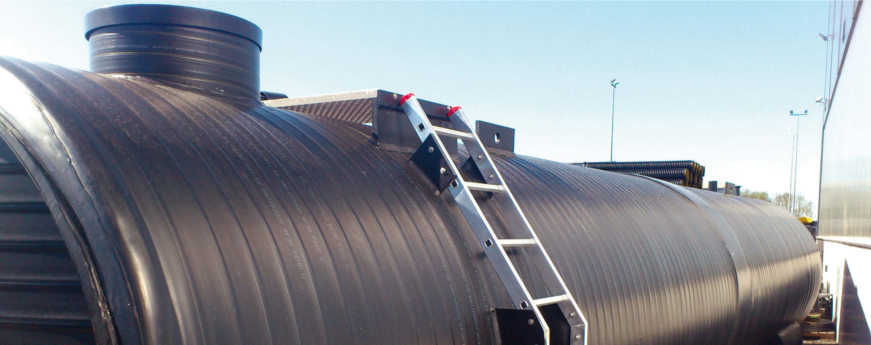
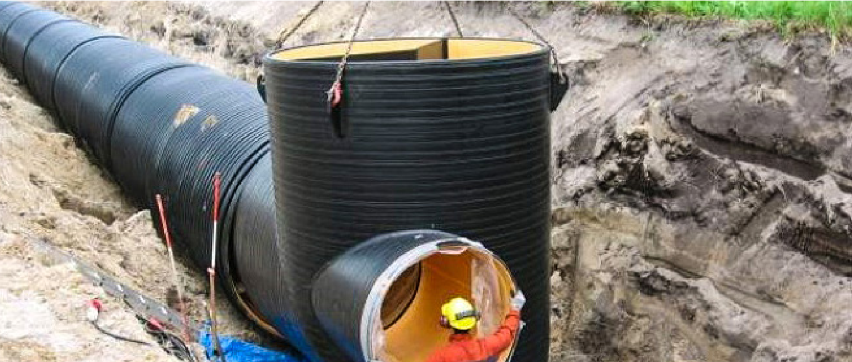
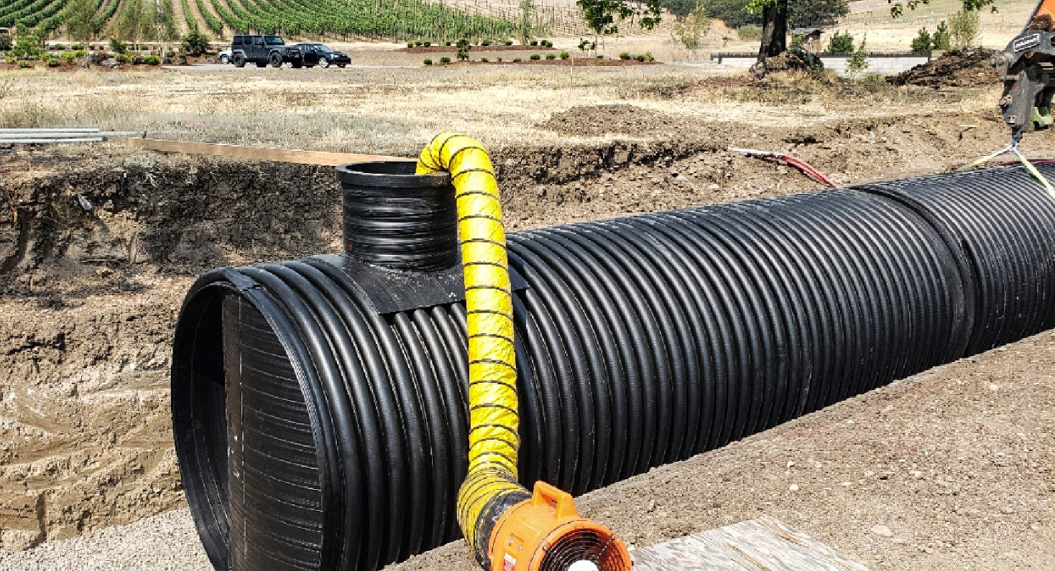
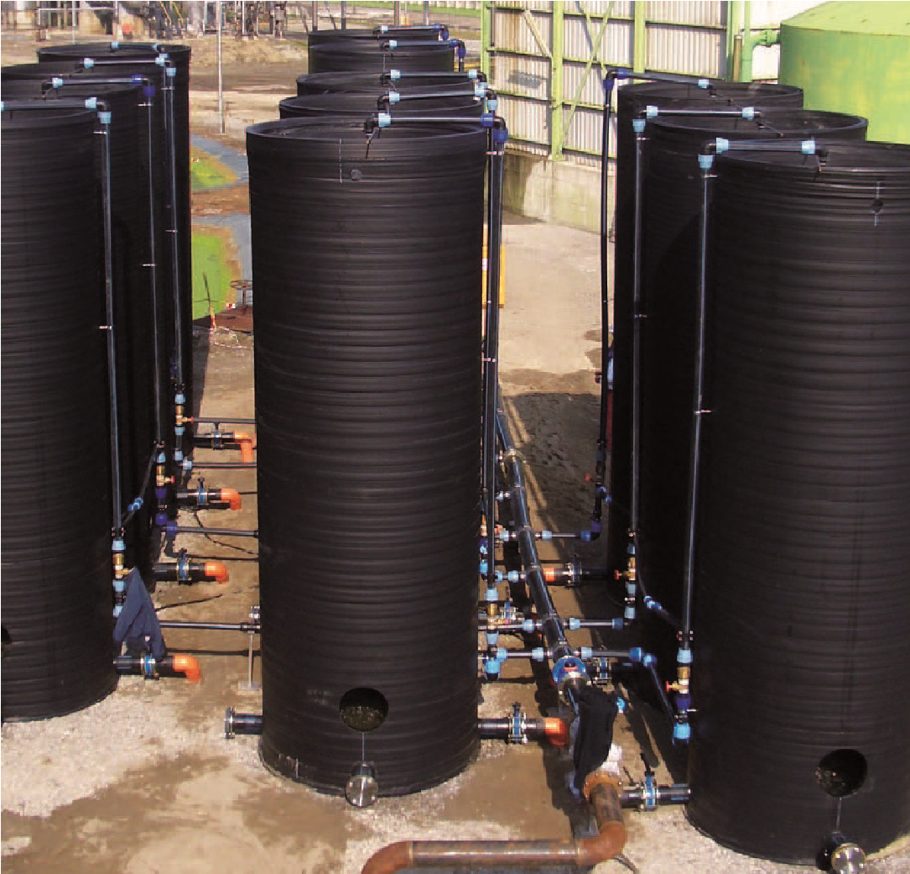
Supporting products and services from Oregon not only stimulates local economic growth but also reflects a dedication to quality, craftsmanship, and sustainability. By prioritizing Oregon-made offerings and collaborating with local businesses, we contribute to our community’s prosperity while honoring our state’s rich heritage of innovation and production. Let’s take pride in supporting Oregon-made goods to enhance the vitality of our local industries and build a brighter future for all. OR 279a.120 encourages resident bidders, but let’s also emphasize the importance of choosing “Oregon Made.”
For more information contact our team at
1-888-
KRAHUS
1-888-457-2487
sales@KRAHUSA.com
Detention Tank
Stormwater Retention Tank
Storage Tank
Landfill Collection Tanks
KRAHUSA LLC www.KRAHUSA.com
3840 NW Bus Evans Lane, Prineville, OR 97754
Page 4 Copywright© 2023 KRAHUSA LLC

